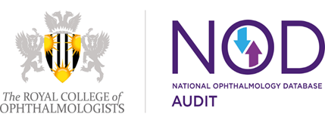
National Ophthalmology
audit Database (NOD)
Opt-in Form
Please complete and sign this form, and e-mail to noa.project@rcophth.ac.uk

On behalf of (Name of organisation), we understand that the Healthcare Quality Improvement Partnership (HQIP) will cease to commission the National Ophthalmology Database Audit on 31 August 2019. The Royal College of Ophthalmologists (RCOphth) is seeking to retain the data contributed to date by this organisation (including historic data from 2010) and intend to continue the audit under the governance and controllership of The Royal College of Ophthalmologists. All data will be held in strict accordance with GDPR and stored and analysed securely at the RCOphth NOD Delivery Unit located at Gloucestershire Hospital NHS Foundation Trust. Our instruction relating to the data submitted to the audit to date is as follows:

(please tick as appropriate):
Opt-in to (Name of organisation) data being stored by the RCOphth after 31 August 2019

Do not want the RCOphth to store any data contributed by (Name of organisation) after 31 August 2019

Please note that if we do not receive the completed opt in form by Friday 02 August 2019, or if you do not want the RCOphth to continue the store data after 31 August 2019, any patient record-level data contributed by (Name of organisation) will be deleted by RCOphth on this date. Not providing explicit opt in consent means the RCOphth NOD will not be able to provide unit historic or surgeon level data including the most recent data analysis for 01 August 2017 to 01 September 2018.

The RCOphth will establish a data sharing agreement with all centres that opt-in to their data being stored after 31 August 2019 and for future participation in the audit.

Organisation for which consent is provided: (Name of organisation)

Position: Caldicott Guardian

Name

Signature | Date

Position: Clinical Lead for Ophthalmology

Name

Signature | Date

